

**Name:- THULASIKUMAR REDDY CN**

**USN:- 21MCAR0079**

**Stream:- MCA (SCT)**

**Subject :- Microsoft Azure**

# Activity-1: Case-Study

**Submitted To :- Dr. Bhuvana**

**Q.** How to configure virtual networks for the case study below on theAzure portal.

Consider the fictional organization Vijayam Ltd, which is in the process of migrating infrastructure and applications to Azure. In your role as network engineer, you must plan and implement three virtual networks and subnets to support resources in those virtual networks.

The CoreServicesVnet virtual network is deployed in the East Indian (Kolkatta)region. This virtual network will have the largest number of resources. It will have connectivity to on-premises networks through a VPN connection. This network will have web services, databases, and other systems that are key to the operations of the business. Shared services, such as domain controllers and DNS also will be located here. A large amount of growth is anticipated, so a large address space is necessary for this virtual network.

The ManufacturingVnet virtual network is deployed in the South Indian region(Karnataka) , near the location of your organization's manufacturing facilities. This virtual network will contain systems for the operations of the manufacturing facilities. The organization is anticipating a large number of internal connected devices for their systems to retrieve data from, such as temperature, and will need an IP address space that it can expand into.

The ResearchVnet virtual network is deployed in the West India region (Mumbai), near the location of the organization's research and development team. The research and development team uses this virtual network. The team has a small, stable set of resources that is not expected to grow. The team needs a small number of IP addresses for a few virtual machines for their work.

**Solution:**



Research

System

Subnet

10.40.0.0/2

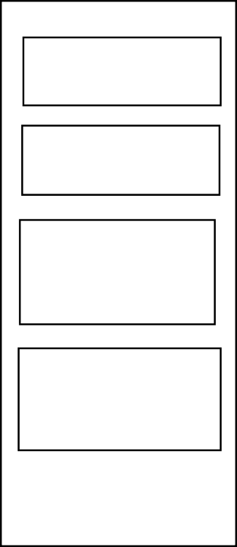

Public web

service Subnet

10.20.30.0/24

Shared

services

Subnet

10.20.10.0/24

Database

Subnet

Gateway

Subnet



Senesor Subnet

310.30.22.0/24

Senesor Subnet 2

10.30.21.0/24

Senesor Subnet

110.30.20.0/24

Manufacturing

system

Subnet

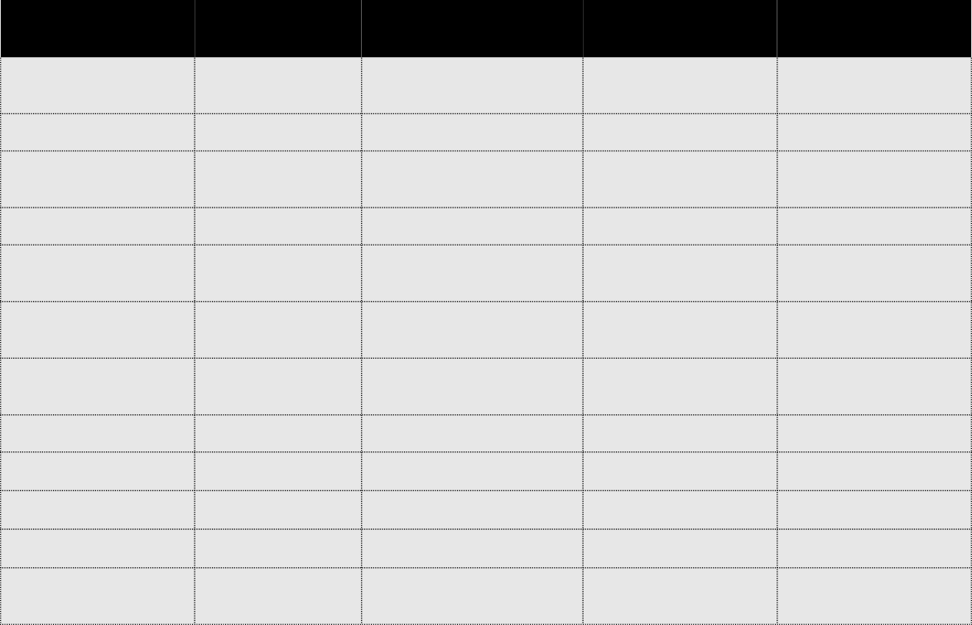

**Virtual**

**Network**

CoreServices

Vnet

**Region**

**Virtual network**

**address**

**space**

10.20.0.0/16

**Subnet**

**name**

**Subnet**

Kolkatta

Gateway

Subnet

10.20.0.0/27

Shared Services

10.20.10.0/24

Subnet

Database

Subnet

10.20.20.0/24

Public Web

10.20.30.0/24

Service

Subnet

Manufacturing

Vnet

Karnataka

10.30.0.0/16

Manufacturing

System

Subnet

SensorSubnet1

SensorSubnet2

SensorSubnet3

10.30.10.0/24

10.30.20.0/24

10.30.21.0/24

10.30.22.0/24

Research

Vnet

Mumbai

10.40.0.0/16

Research System

10.40.0.0/24

Subnet